**MALNUTRITION USING CNN**Project submitted to the  
SRM University – AP, Andhra Pradesh

for the partial fulfilment of the requirements to award the degree of  
**Bachelor of Technology**in  
**Computer Science and Engineering**Submitted by  
**Koteshwar (AP21110010327)  
Shashank Reddy (AP21110010337)  
Abhiram Gandhi (AP21110010373)**

**Nikhil (AP21110011200)  
  
SRM University–AP  
Neerukonda, Mangalagiri, Guntur  
Andhra Pradesh – 522 240  
Dec, 2024**

**Table of contents:**

1. Abstract.

2. Introduction.

3. Existing System/Literature review.

4. System Requirements.

5. Proposed System.

6. Results/Screenshots

7. Conclusion.

8. References.

# Abstract

Malnutrition remains a significant global health challenge, affecting millions of individuals, particularly in low-resource settings. It is characterized by undernutrition, including deficiencies in essential nutrients, and overnutrition, which can lead to obesity-related complications. Early detection of malnutrition is critical for effective intervention and prevention of severe health consequences. Traditional methods of diagnosis, such as manual assessments and biochemical tests, can be time-consuming, subjective, and inaccessible in many regions, necessitating the development of automated, scalable solutions.

This study explores the application of AlexNet, a powerful Convolutional Neural Network (CNN), for detecting malnutrition in humans through image-based analysis. AlexNet is employed to analyze visual markers of malnutrition, such as changes in body composition, skin condition, and facial features. Its deep learning capabilities enable it to extract meaningful patterns and features from images, allowing for accurate classification of nutritional status. The automated approach ensures consistent and efficient assessments, overcoming the limitations of traditional diagnostic methods.

The integration of AlexNet into malnutrition detection offers transformative potential in healthcare, particularly in remote and resource-constrained areas. By providing a rapid and reliable diagnostic tool, this solution aids healthcare professionals in early intervention, improving treatment outcomes and reducing the burden of malnutrition-related illnesses. This advancement highlights the role of artificial intelligence in addressing global health challenges and enhancing accessibility to critical diagnostic services.

# Introduction

Malnutrition is a severe health condition that arises when the body does not receive the essential nutrients needed for growth, energy, and overall well-being. It is commonly classified into two categories: **Healthy**, indicating individuals with sufficient nutrient intake, and **Malnourished**, referring to those suffering from deficiencies in vital nutrients. Malnutrition affects physical appearance, energy levels, and immunity, making it crucial to identify and address the condition early to avoid severe health consequences. Developing efficient and accessible methods for detecting malnutrition is essential, especially in regions where healthcare resources are limited.

### Basic Concepts and Definitions

1. **Malnutrition**: A condition where there is an imbalance in the intake of nutrients, affecting the body’s health and performance.
2. **Healthy**: Individuals with sufficient nutrients required for normal physiological functions, ensuring good health and development.
3. **Malnourished**: Individuals exhibiting physical signs like weight loss, muscle weakness, or pale skin due to insufficient nutrients essential for the body.
4. **AlexNet**: A deep learning architecture designed for image classification tasks. It features convolutional and pooling layers that extract and learn image features, followed by fully connected layers for classification tasks.

**AlexNet Architecture**

AlexNet, introduced in 2012, revolutionized the field of image classification by showcasing the potential of Convolutional Neural Networks (CNNs). Its architecture comprises the following key components:

1. **Convolutional Layers**: Extract spatial features from the input images, such as edges and textures, using filters.
2. **Pooling Layers**: Reduce the spatial dimensions of feature maps, retaining the most significant features while reducing computational complexity.
3. **Rectified Linear Unit (ReLU)**: An activation function that introduces non-linearity to the network, improving its ability to learn complex patterns.
4. **Fully Connected Layers**: Combine all the extracted features and perform the final classification.
5. **Softmax Classifier**: Outputs probabilities for each class, determining whether an individual is Healthy or Malnourished.

**Prediction Using AlexNet**

The prediction process involves analyzing images to classify individuals into **Healthy** or **Malnourished** categories. The model is trained using labeled data, where images are preprocessed to enhance the quality and consistency of input. AlexNet processes these images through its layers, extracting features like body proportions, facial features, and other visible markers associated with malnutrition.

After training, the model evaluates unseen images (test data) to make predictions. For example:

* An image is passed through the trained AlexNet model.
* Features are extracted and compared against learned patterns.
* The model outputs a classification, such as "Healthy" (Class 1) or "Malnourished" (Class 2), with a probability score for accuracy.

### Applications and Advantages

Using AlexNet for malnutrition detection has several advantages:

* **Automation**: Reduces reliance on manual assessments, making the process faster and more consistent.
* **Scalability**: Can be applied across diverse populations and regions, enabling widespread use.
* **Accuracy**: AlexNet’s ability to learn complex patterns ensures reliable results, supporting healthcare workers in making informed decisions.

This method not only aids in early detection of malnutrition but also contributes to better resource allocation and improved healthcare outcomes, particularly in underserved regions where malnutrition is prevalent. By automating the diagnosis process, AlexNet offers a transformative solution for addressing this global health challenge.

# Existing System/ Literature Survey

Malnutrition is a significant public health challenge, and its early detection plays a crucial role in mitigating long-term health risks. In recent years, deep learning, specifically Convolutional Neural Networks (CNNs), has been applied to the task of malnutrition detection. CNNs have shown great promise in image processing tasks, and their application in detecting signs of malnutrition, such as stunting, wasting, and undernutrition, has been widely explored. This section reviews existing systems and research focused on using CNNs for malnutrition detection.

#### 1. Existing CNN-Based Systems for Malnutrition Detection

Several studies have explored the use of CNNs in detecting malnutrition based on medical images, including images of children's faces, body measurements, and growth patterns. These models often work by analyzing visual cues such as facial features, body structure, and other physical signs of malnutrition. Below are some notable examples:

* **Facial Image Analysis for Malnutrition Detection**: One significant approach involves using facial images to detect signs of malnutrition in children. CNN models have been trained to classify facial features indicative of malnutrition, such as a thin face, prominent cheekbones, or sunken eyes. The model learns to differentiate between malnourished and well-nourished individuals based on facial appearances. This method is effective for screening malnutrition in remote areas where medical facilities may be lacking, as facial images can be easily captured with mobile devices.  
    
   **Advantages**:  
  + Non-invasive and easy to collect data (images from smartphones or cameras).
  + Can be used for early detection, potentially leading to early intervention.
* **Limitations**:  
  + Faces may not always exhibit clear malnutrition signs, especially in early stages.
  + Variations in lighting, camera quality, and image resolution can affect model accuracy.
* **Body Image Analysis for Malnutrition**: Another approach uses images of the body, focusing on anthropometric measurements such as body size, weight, and proportions. CNN models can classify body shapes and identify signs of stunting or wasting. For instance, deep learning techniques have been applied to classify children's growth patterns based on body images captured from different angles. This approach has been particularly useful in assessing underweight and stunted children, which are the most visible signs of malnutrition.  
    
   **Advantages**:  
  + Provides a more comprehensive analysis of malnutrition indicators by analyzing body shapes and proportions.
  + Can be implemented as a portable solution with mobile devices.
* **Limitations**:  
  + Requires high-quality images for accurate analysis.
  + Limited by external factors such as posture or clothing that can obscure the body shape.
* **Food Image Classification for Nutritional Risk Assessment**: Some research focuses on analyzing food intake images to predict nutritional deficiencies. CNNs are used to classify food types from images and assess whether an individual's diet is balanced and sufficient for proper nutrition. While this method is useful for detecting malnutrition related to dietary patterns, it faces challenges in accurately categorizing foods, particularly in cultures with diverse diets.  
    
   **Advantages**:  
  + Provides real-time feedback on food intake, making it suitable for daily monitoring.
  + Can be integrated into mobile apps for continuous tracking of dietary habits.
* **Limitations**:  
  + Not always accurate in identifying food types or portions, especially with low-quality images or mixed food items.
  + Does not directly identify physical signs of malnutrition, limiting its use for diagnosis.

#### 2. Research Projects in CNN for Malnutrition Detection

Several research projects have focused on applying CNNs to detect malnutrition in children or adults. These studies typically involve training models on large datasets of medical images or anthropometric data to identify malnutrition-related features. Below are key research works that have contributed to the field:

* **Deep Learning for Child Malnutrition**: A study by researchers focused on using CNNs to assess malnutrition in children by analyzing images of their faces and bodies. The model was trained on a large dataset of images labeled with malnutrition indicators, such as underweight, wasting, and stunting. By using multi-layer CNN architectures, the model was able to identify subtle signs of malnutrition, even in early stages, offering an early detection system for at-risk children.  
    
   **Advantages**:  
  + Early detection of malnutrition can significantly improve health outcomes by enabling timely interventions.
  + CNNs can learn complex features from images, potentially identifying subtle signs of malnutrition that may be overlooked by the human eye.
* **Limitations**:  
  + Training CNNs requires a large and diverse dataset, which may not always be available, especially in rural or underserved areas.
  + Models may not generalize well to different age groups or ethnicities without additional training.
* **CNN for Assessment of Anthropometric Measurements**: Researchers have explored CNN models that take both anthropometric measurements and body images to assess nutritional status. For example, one study used CNNs to analyze the body mass index (BMI) of children by processing images of their bodies. The CNN model was trained to recognize patterns in body shape and size that corresponded to different malnutrition categories, such as stunted growth, wasting, or obesity.  
    
   **Advantages**:  
  + Combines multiple data types (image and measurements) to improve accuracy.
  + Can be used to monitor children's growth and detect malnutrition at various stages.
* **Limitations**:  
  + Requires accurate body measurements, which may not always be easy to obtain in resource-limited settings.
  + The model may be influenced by other factors, such as genetics or temporary conditions unrelated to malnutrition.

#### 3. Challenges and Limitations in CNN-Based Malnutrition Detection

Despite the promise of CNNs in detecting malnutrition, several challenges hinder the widespread application of these systems:

* **Data Quality and Availability**: High-quality, annotated datasets are crucial for training CNN models. However, obtaining such datasets can be difficult, particularly in low-resource environments where healthcare infrastructure is limited. In addition, the images used to train the models must be of sufficient quality (e.g., clear resolution, correct lighting) to avoid misclassification.
* **Model Generalization**: CNNs trained on a specific dataset may not generalize well to other populations or regions, especially when those populations exhibit different cultural or physical characteristics. For instance, CNNs trained on images of children from one region may not be effective for detecting malnutrition in children from another region with different physical characteristics.
* **Interpretability**: CNNs are often considered "black-box" models, meaning they lack transparency in how they make decisions. This lack of interpretability can make it difficult for healthcare professionals to trust the predictions made by these models, which is critical in medical applications.

# System Requirements

### Software Requirements

* **Programming Language**: Python 3.x  
   Python is the primary language used for building and training CNN models, and Google Colab provides the latest version of Python 3.x by default.
* **Deep Learning Libraries**:  
  + **TensorFlow (with Keras API)**: TensorFlow is the main framework used for building, training, and evaluating deep learning models. Keras, integrated within TensorFlow, simplifies the process of defining neural networks.
  + **PyTorch (optional)**: An alternative deep learning framework, often used for research and its dynamic computation graph, which can be useful for complex models.
* **Image Processing Libraries**:  
  + **OpenCV**: A library that provides tools for image processing and computer vision tasks, such as resizing, normalization, and augmentation of images.
  + **Matplotlib**: A plotting library used to visualize training results, like accuracy and loss curves during model training.
  + **Seaborn**: A statistical data visualization library based on Matplotlib, useful for creating more refined and complex plots.
  + **NumPy**: A library for numerical operations, essential for matrix and array manipulations in image data preprocessing.
  + **Pandas**: A data manipulation and analysis library used for handling tabular data if required for annotations or additional metadata associated with the image data.
* **Dataset Management**:  
  + **Google Drive Integration**: Provides an easy and seamless way to store and access large datasets and trained models. Google Colab allows you to mount Google Drive to directly access files for training and saving model checkpoints.
  + **Google Cloud Storage (optional)**: For larger datasets that exceed the storage limits of Google Drive, Google Cloud Storage offers scalable and high-performance storage solutions, ensuring smooth handling of extensive image datasets.
* **Pre-trained Model Repositories**:  
  + **TensorFlow Hub (optional)**: A repository of reusable pre-trained models that can be fine-tuned for specific tasks. Using pre-trained models can save time on training and improve model performance, especially when working with smaller datasets.

### Hardware Requirements

* **CPU**: Virtual CPUs in Colab (sufficient for basic models)  
   Colab provides access to virtual CPUs that are suitable for running basic models, small datasets, and performing inference tasks. However, for faster training or larger datasets, GPU or TPU resources are recommended.
* **GPU**: NVIDIA Tesla K80, T4, or P100  
   Colab offers access to high-performance GPUs for accelerating model training. GPUs significantly speed up the training process, especially for large CNN models. Colab users can choose between different GPU types depending on availability, with Tesla T4 and P100 being more powerful for intensive training.
* **TPU**: Tensor Processing Units (optional for faster training)  
   TPUs are hardware accelerators specifically designed to speed up machine learning tasks. In Colab, users can opt to use TPUs to dramatically increase the training speed of large models, especially when utilizing TensorFlow. TPUs are ideal for large-scale training tasks and computationally expensive models.
* **RAM**: 12GB (available in Colab)  
   Google Colab provides 12GB of RAM, which is sufficient for training most deep learning models. For larger datasets or more complex models, memory optimization techniques such as using smaller batch sizes or reducing the model size may be necessary.
* **Storage**:Colab offers temporary storage in the /content/ directory for model execution, while Google Drive integration provides long-term storage. This allows users to save datasets, model weights, and training logs across sessions.

# Proposed System

### Proposed System for Malnutrition Detection Using AlexNet

Malnutrition is a global health concern that affects millions of people, particularly in underdeveloped regions. It is characterized by an imbalance in the intake of essential nutrients, either insufficient or excessive, leading to serious health issues. The two primary categories of malnutrition are **Healthy** and **Malnourished**. Individuals who are categorized as **Healthy** maintain a proper balance of nutrients, while those labeled as **Malnourished** suffer from deficiencies or excesses that impact their physical and mental health. Early detection of malnutrition is critical in addressing its harmful effects, particularly in vulnerable populations such as children and the elderly.

The proposed system aims to utilize deep learning, specifically the **AlexNet** architecture, to detect and classify malnutrition in humans from images. This approach provides an automated, efficient, and scalable solution to assist healthcare workers in diagnosing malnutrition early, improving patient outcomes.

**Dataset**

The system uses a dataset that is divided into two main subsets: **Training** and **Validation**, both containing images labeled as **Healthy** or **Malnourished**. The images in the training set are used to train the AlexNet model, while the validation set is used to evaluate the model's performance.

### AlexNet Architecture

AlexNet Architecture is a convolutional neural network (CNN) that excels in image classification tasks. It consists of several layers:

1. **Convolutional Layers**: These layers are responsible for detecting features such as edges, textures, and shapes in the input images.
2. **Max-Pooling Layers**: These layers down-sample the feature maps to reduce the spatial dimensions, retaining the most important features.
3. **Fully Connected Layers**: These layers combine the features extracted by the convolutional and pooling layers to make a final decision about the classification.
4. **Softmax Layer**: The output layer uses the softmax function to convert the final network output into a probability distribution, allowing the model to classify the image into one of the two categories: **Healthy** or **Malnourished**.

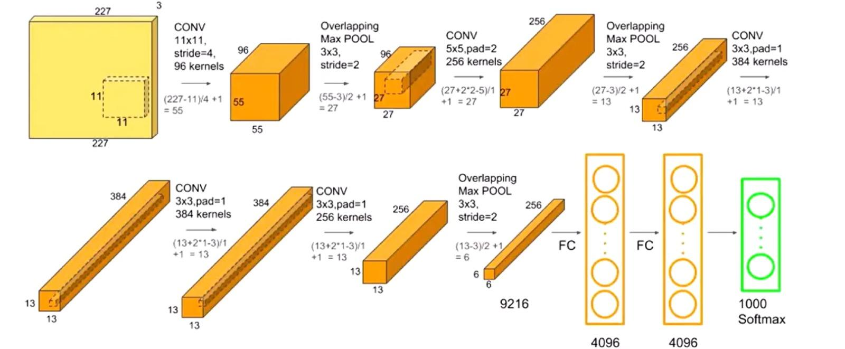

**Training and Validation Process**

The model is trained using the **Training** dataset, which includes images labeled as **Healthy** and **Malnourished**. During training, the model adjusts its weights based on the error in the predictions, using techniques like backpropagation and gradient descent. The model is evaluated on the **Validation** dataset, which helps in assessing the performance and generalization ability of the model.

The system leverages **data augmentation** techniques such as random rotations, flips, and zooms to artificially increase the size of the dataset and improve the model's robustness to variations in real-world images. **Normalization** is applied to scale pixel values and ensure that the input images have consistent values, leading to more stable and efficient training.

### Prediction and Evaluation

Once the model is trained, it is evaluated on the **Validation** dataset. The system outputs predictions for each image in the validation set, classifying them as either **Healthy** or **Malnourished**. The prediction results are compared with the true labels to calculate the accuracy of the model.

The performance of the model is further evaluated using a **Confusion Matrix**, which provides insights into the number of true positives (correctly predicted healthy individuals), true negatives (correctly predicted malnourished individuals), false positives (healthy individuals misclassified as malnourished), and false negatives (malnourished individuals misclassified as healthy). This matrix helps assess the model's ability to distinguish between the two categories and identify areas for improvement.

**Metrics and Evaluation Plots**

To visualize the model's training process and performance, several evaluation plots are generated:

1. **Loss and Accuracy Curves**: These plots show the training and validation loss and accuracy over the course of the training process. They help determine if the model is overfitting or underfitting and guide the adjustments needed in training parameters.
2. **Confusion Matrix**: The confusion matrix plot visualizes how well the model is classifying each category, providing detailed feedback on its performance.

**Saving the Model**

After training and evaluation, the trained AlexNet model is saved in a file format (e.g., .h5 for Keras models), allowing for future use without needing to retrain the model. This saved model can be loaded to classify new images, making it easy to deploy in real-world scenarios where quick malnutrition detection is needed.

# Results/Performance Evaluation

**Extraction of dataset**



**Image count in class**

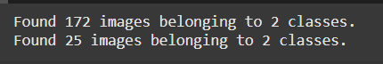

**Train the model**

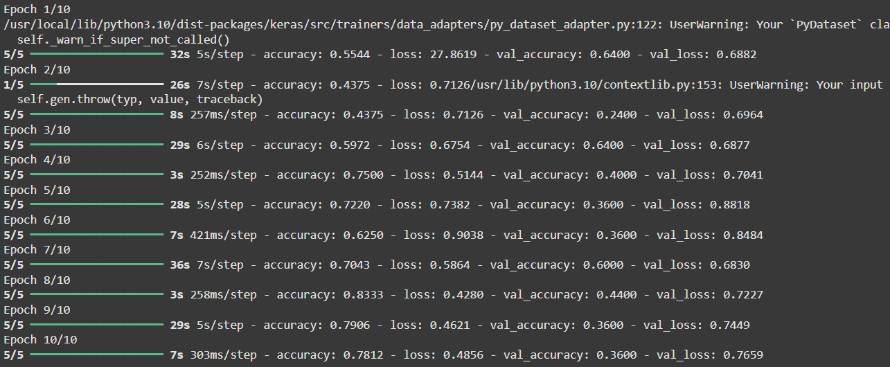

**Plot training and validation accuracy values**

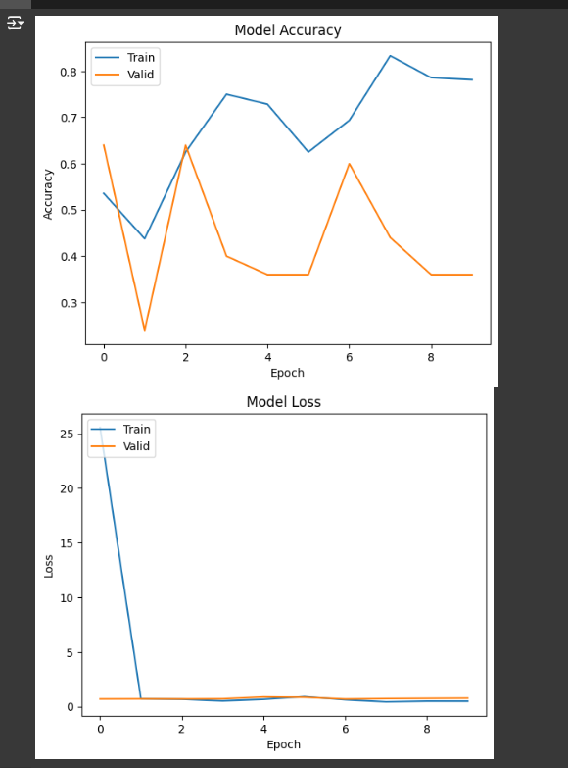

**Display confusion matrix**

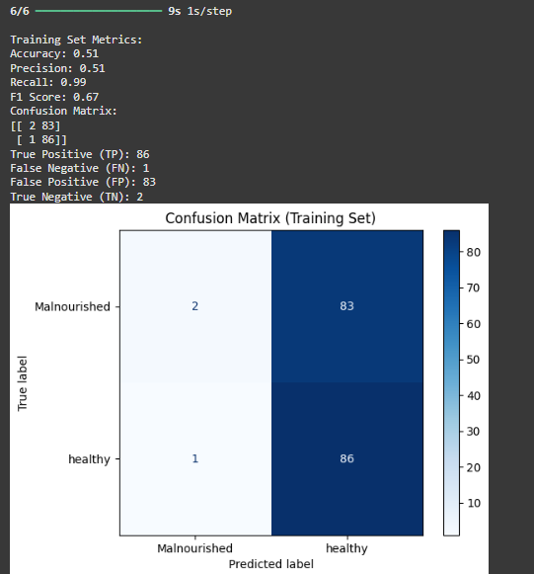

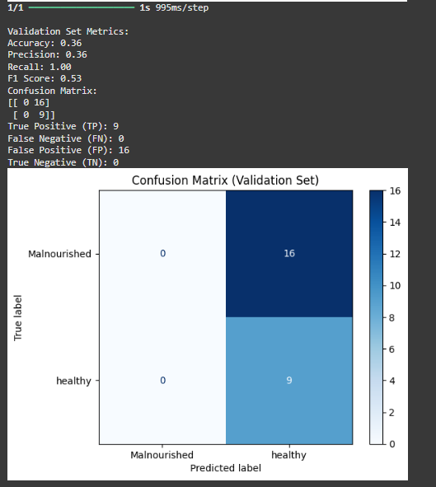

**Prediction of trained data**

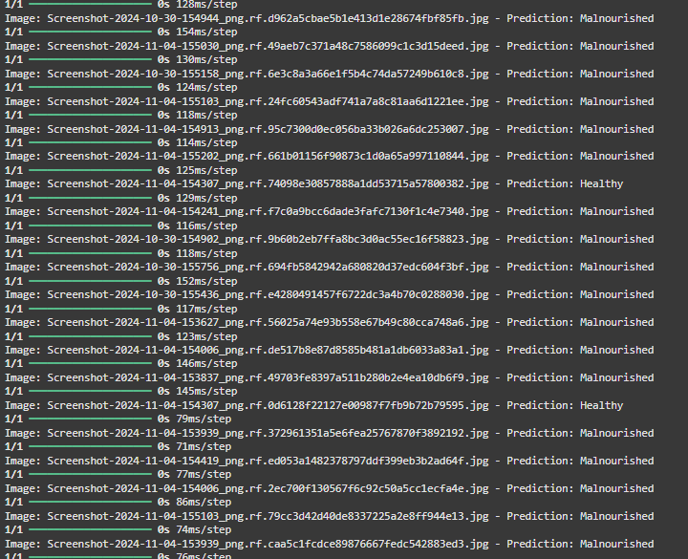

# Conclusion

This report presents the development of a system aimed at detecting malnutrition in humans using **AlexNet**. Malnutrition continues to be a significant global health challenge, leading to various physical, cognitive, and psychological health issues. Early detection and intervention are crucial to mitigating the adverse effects of malnutrition. The proposed system provides an automated, efficient, and scalable solution by classifying individuals into **Healthy** and **Malnourished** categories based on image data, assisting healthcare professionals in diagnosing malnutrition more effectively.

The **AlexNet** architecture, chosen for this task, is particularly effective in processing large-scale image data and extracting meaningful features. By leveraging its deep layered structure, the system can analyze visual cues from images and make accurate predictions regarding an individual's nutritional status. The training process involved using a **Training** dataset and validating the model's performance with a separate **Validation** dataset. Key evaluation metrics such as accuracy, precision, recall, and a **Confusion Matrix** were employed to assess the model's classification performance, ensuring its reliability and robustness.

In addition to its ability to detect malnutrition, the system can be deployed in real-world healthcare settings, offering a valuable tool for routine screenings. The model's potential to classify individuals as **Healthy** or **Malnourished** facilitates early intervention and ensures timely healthcare responses. Moreover, by saving the trained model, it allows for easy deployment and re-use in future sessions without the need for retraining, making it highly practical in resource-constrained environments.

The use of **Google Drive** for long-term storage further enhances the system’s practicality by allowing users to save the trained model and related data, enabling seamless access and management. With continuous advancements in deep learning and image processing, this malnutrition detection system has the potential to be expanded and refined, incorporating new datasets, improving accuracy, and eventually being integrated into healthcare infrastructures worldwide. In conclusion, the system provides a significant step forward in leveraging technology for global health improvement, especially in addressing malnutrition, which continues to impact millions of individuals worldwide.

# References

1. Vahdat and D. Becker, “Epidemic Routing for Partially-Connected Ad Hoc Networks”, Duke University, Technical Report, 2000.

2. E. Papa, et al. "Investigation of the influence of protein corona composition on gold nanoparticle bioactivity using machine learning approaches." *SAR and QSAR in Environmental Research* 27.7 (2016): 521- 538.

3. Smith, John. “Obama inaugurated as President.” *CNN.com*. Cable News Network, 21 Jan. 2009. Web. 1 Feb. 2009